Participants’ Thoughts about Future Sexual Activity
The Pre-Test and Post-Test include 5 multiple-choice questions about participants’ thoughts about sexual activity. Participants could skip questions by selecting “Prefer not to answer”.

Of the 9 participants who answered these questions on the Pre-Test and 3 participants who responded to these questions on the Post-Test, a higher proportion of participants reported feeling prepared to say no if someone wanted to have sex without a barrier method, to say no if they were not ready for sex, to go to a doctor for birth control, to use birth control if they are worried about getting pregnant, and to use a barrier method in future sexual activity after MPC+, compared to before. _ of the Post-Test participants, however, reported feeling unsure or did not feel prepared to _.
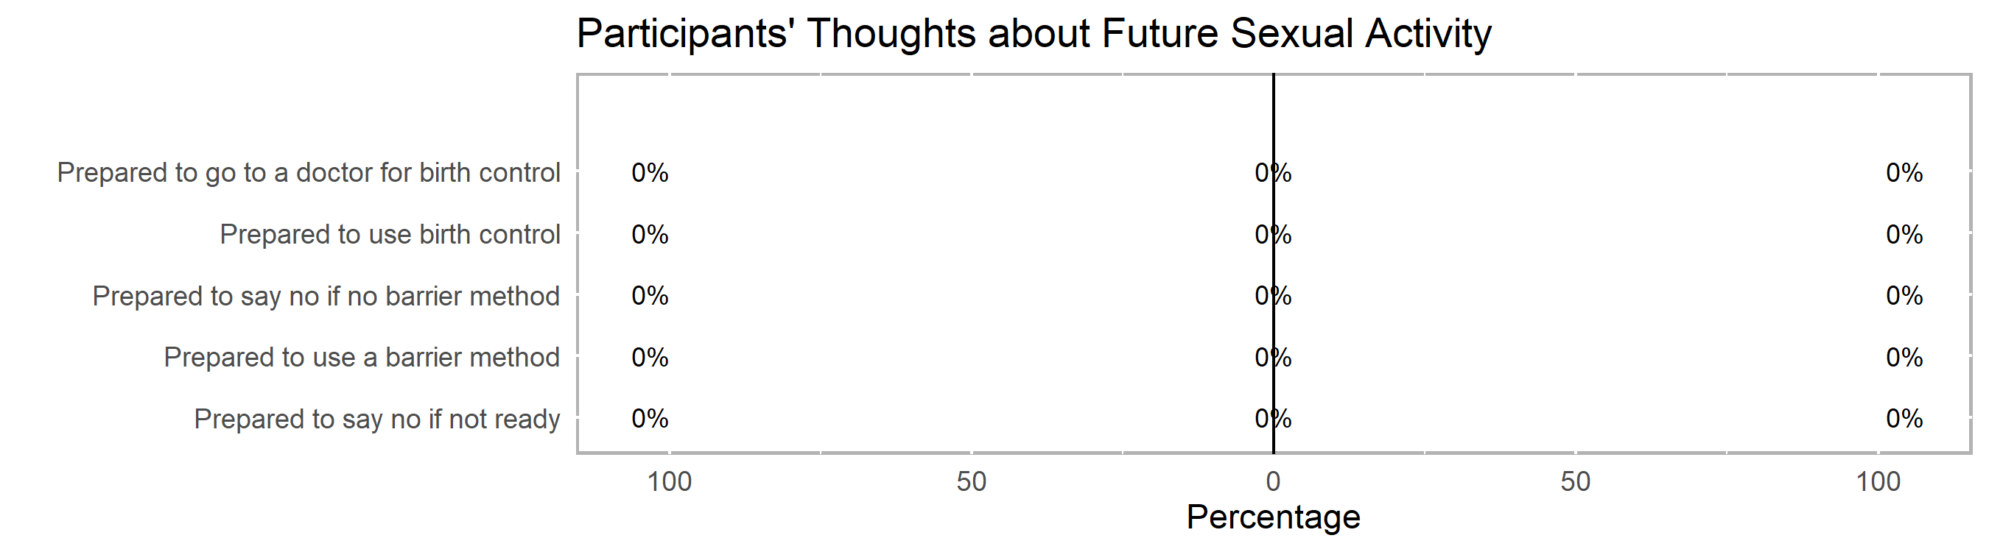

Appendix A

Participants’ Knowledge about Sexual & Reproductive Health
The knowledge portion of the Pre-Test consists of 16 short-answer, multiple-choice, check-all-that-apply, and true/false questions about relationships, birth control (e.g., IUD, implant, shot, ring, patch, pill), and barrier methods (e.g., condoms, dental dams). Participants could earn partial credit on check-all-that-apply questions for a total of 17 possible points*.

- Range of scores: 18% to 88% correct
- Median score: 38% correct
- Mean score: 8 out of 17 possible points* or 45% correct
(right skew: higher-scoring outliers pulling the distribution to the right)
- Mode: tri-modal
- Standard deviation: 23% (quite the/some spread of scores)
Over the course of this group, the average test score increased by 5 percentage points (= post% – pre%), meaning an 8% increase in average test scores (= (post% – pre%) ÷ pre% × 100). This difference, however, is not a statistically significant gain in the post-test scores (t=0.6446, df=5 p=0.5476), meaning this change was not likely due to chance.

Highlights & Recommendations
The following table includes the number of participants (and percent of the group in parentheses) who answered each question correctly. These were the most difficult questions for your group with recommendations from your TA provider about where to focus lessons:

 | % Participants who answered correctly
Question* | Pre-  Test  (n=9) | Post-  Test  (n=6) | Percent Change
Q35: True or False? Water-based lubricants can cause latex condoms to break. | 57% | 100% | 75%
Q26: What is PrEP (Pre-Exposure Prophylaxis)? (Medication that reduces risk of getting HIV) | 29% | 50% | 72%
Q36: True or False? Emergency contraception (like Plan B) can be taken up to 5 days (or 120 hours) after having unprotected sex in order to prevent pregnancy. | 29% | 50% | 72%
Q32*: If used correctly, withdrawal (or pulling a penis from a vagina before ejaculating) is effective in protecting people from which of the following? (Check all that apply: Neither pregnancy nor STIs.) | 57% | 75% | 32%
Q25: Which of the following is FALSE about consent? (People cannot take back consent.) | 43% | 50% | 16%
Q37: True or False? You can get emergency contraception (like Plan B) without a prescription. | 57% | 50% | -12%
Q30*: If used correctly, an external/male condom made out of lambskin (that covers a penis or sex toy) is effective in protecting people from which of the following? (Check all that apply: Pregnancy only) | 57% | 33% | -42%
Q31* If used correctly, an internal/female condom (that goes inside a vagina or anus) is effective in protecting people from which of the following? (Check all that apply: Both pregnancy and STIs)
Q27* If used correctly, abstinence (or choosing not to have sex) is effective in protecting people from which of the following? (Check all that apply: Both pregnancy and STIs)
Q34 True or False? A person with an STD/STI who looks and feels healthy cannot give the infection to others.
Q29* If used correctly, an external/male condom made out of latex, polyurethane, or polyisoprene (that covers a penis or sex toy) is effective in protecting people from which of the following? (Check all that apply: Both pregnancy and STIs)
Q28* If used correctly, hormone-based birth control (e.g., IUD, implant, Depo Provera shot, vaginal ring, patch, pill) is effective in protecting people from which of the following? (Check all that apply: Pregnancy only)
Q24 Which of the following is NOT considered dating abuse? (All of the above are considered types of abuse.)
Q23 Which of the following is an example of a healthy relationship? (Chemistry)
*Participants were able to check-all-that-apply for some questions to earn partial or full credit.
Percent change = (% correct at post-test − % correct at pre-test) ÷ % correct at pre-test × 100

Appendix B
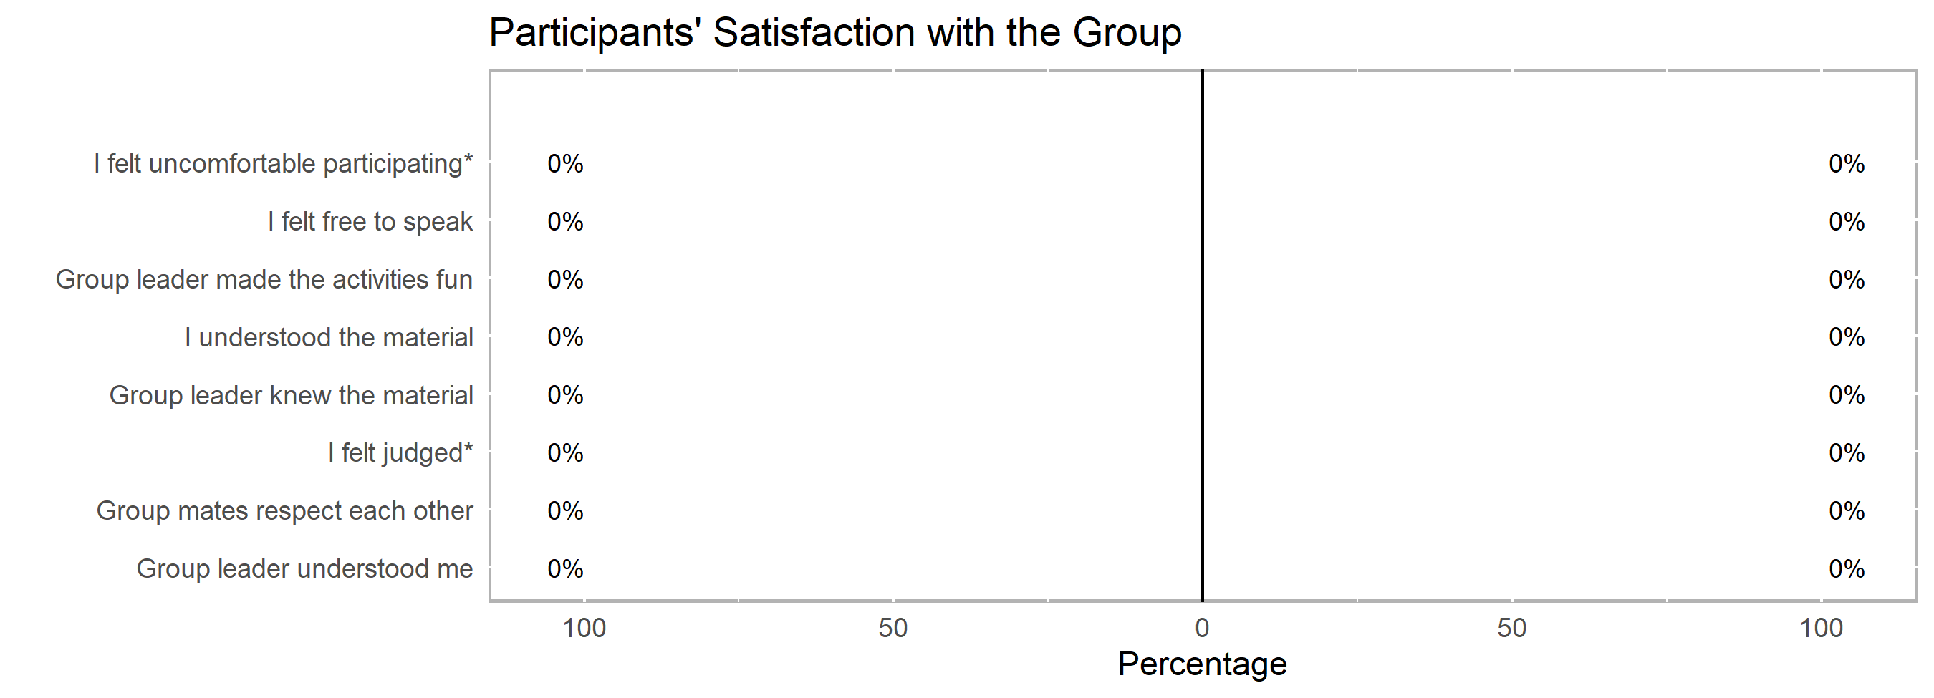
Of the 3 participants that responded to the group satisfaction questions, participants liked how the class was interactive, respectful, and “done in a timely fashion”. Specifically, they liked the role playing, particularly how to use the STOP strategy. Though half of the 3 participants reported feeling uncomfortable participating, it does not seem to be from the facilitation of the class since their input conveyed appreciation for the tone of the class. One participant wrote, “She [the group leader] made sure we [the participants] all felt comfortable and enjoyed class as much as possible. They [the group leaders] made sure no one was uncomfortable to speak and be open.” Other. Another participant wrote, “I think the class was very well thought and the leaders had good information. Personally I think they did there [sic] best.” One future concern that a participant shared was, “The next time they [the group leaders] might not have people they know so they should prepare for a more diverse group of students.”

Statistics calculated on https://www.graphpad.com/quickcalcs/OneSampleT1.cfm?Format=SD

